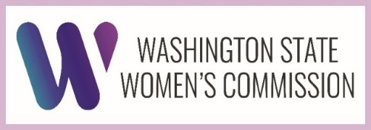

Spring Plenary AGENDA
Virtual
March 28, 2025 | 9:00 am – 12:30 pm

Time | Topic(s) | Presenter(s)
9:00 am | Call to Order  Approval of Minutes and Agenda | Vicki Lowe  Commission Chair
9:05 am | Introduction: Acting Director Kathleen Drew | Kathleen Drew  Acting Director
9:10 am | Activate 3.8 Event Recap: “Girls on the Hill” | Samantha Grono  Economic Initiatives Manager
9:20 am | Legislative Advisor | Senator Lisa Wellman
9:30 am | Updates from the Governor’s Policy Team | Grace Huang  Policy Advisor, Civil Rights & Human Services, Office of the Governor
9:50 am | Legislative Session Update | Samantha Grono  Economic Initiatives Manager  Commissioners
10:00 am | Legislative Advisor | Rep Jamila Taylor
10:10 am | Break | --
10:20 am | Federal Developments around Voting  - The Safeguard American Voter Eligibility (SAVE) act  - Security Services for Elections | Mary Hall,  Thurston County Auditor
10:40 am | Human Trafficking in Washington State  - Data & Data Collection  - MMIWP Crisis | Jeri Moomaw  Founder & Executive Director, Innovations HTC
11:10 am | Legislative Advisor | Rep Mary Dye
11:20 am | Federal impacts on women’s  - Health  - Economic Security & Opportunity  - Safety | Commissioners - “Round Robin”
12:00 pm | Public Comment | Members of the Public
12:30 pm | Plenary Meeting Adjourned | Vicki Lowe  Commission Chair

