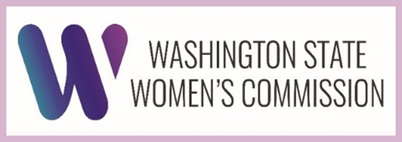 | Fall Plenary Agenda  Virtual  October 10, 2025 | 9:00 am – 11:00 am

Time | Topic(s) | Presenter(s)
9:00 am | Call to Order  Approval of Minutes and Agenda | Vicki Lowe  Commission Chair
9:05 am | Welcome and intro:  Mishani Jack and Misheel Ildbaatar | Brittany Gregory  Executive Director
9:10 am | Housekeeping Items | Brittany Gregory  Executive Director
9:20 am | Legislative Priority updates | Commission Advisors
9:40 am | Legislative Session & Policy | Samantha Grono  Public Policy & Legislative Affairs Manager
9:55 am | Final vote on:  Exec Committee (Chair, Vice-Chair, Secretary) | Vicki Lowe  Commission Chair
10:05 am | Committee Updates  2 minutes each Committee | Commissioners Carrillo, Mukhopadhyay, Lowe, and Director Gregory
10:15 am | Public Comments | --
10:35 am | Open Discussion  What are some creative solutions the State can take to make sure marginalized communities don’t shoulder the brunt of the budget shortfall? | Brittany Gregory  Executive Director
11:00 am | Next Plenary: January 9th  Plenary Meeting Adjourned | Vicki Lowe  Commission Chair

